FRONTEND LOGIN

First Step is to Register
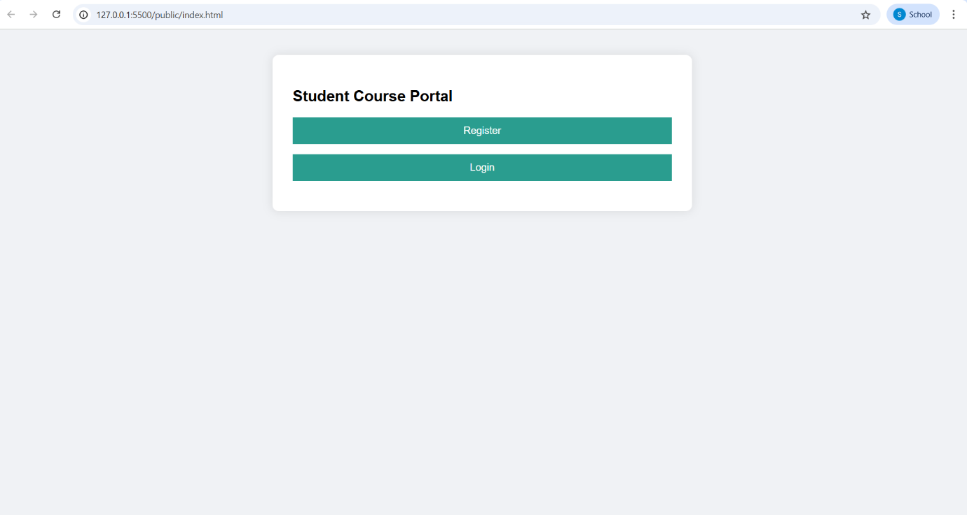

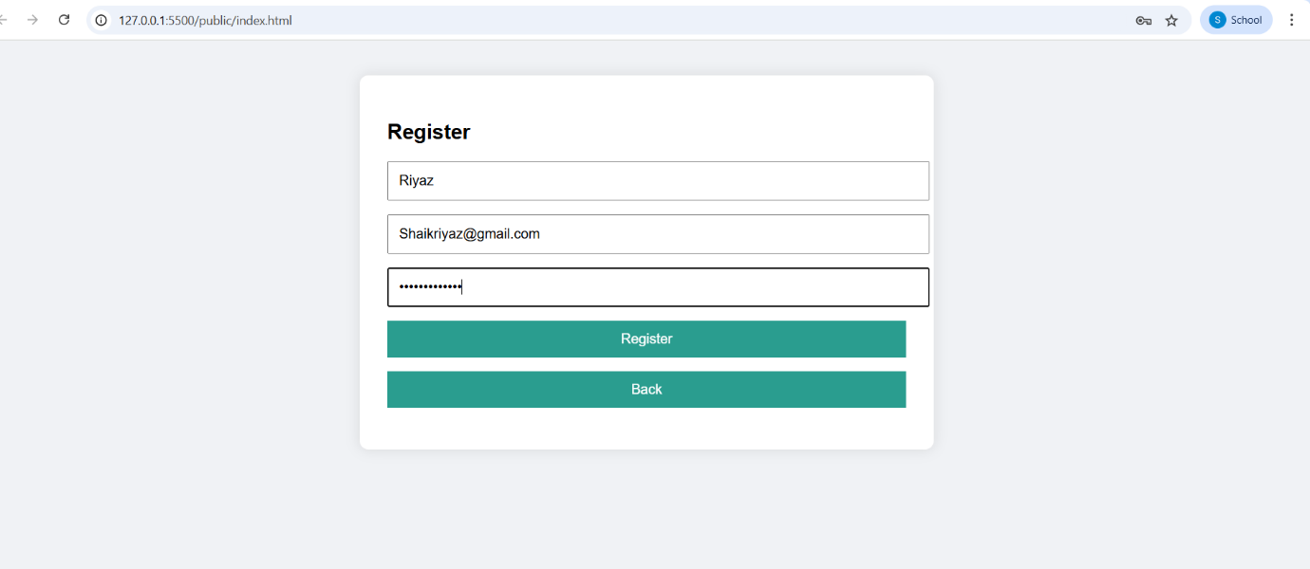
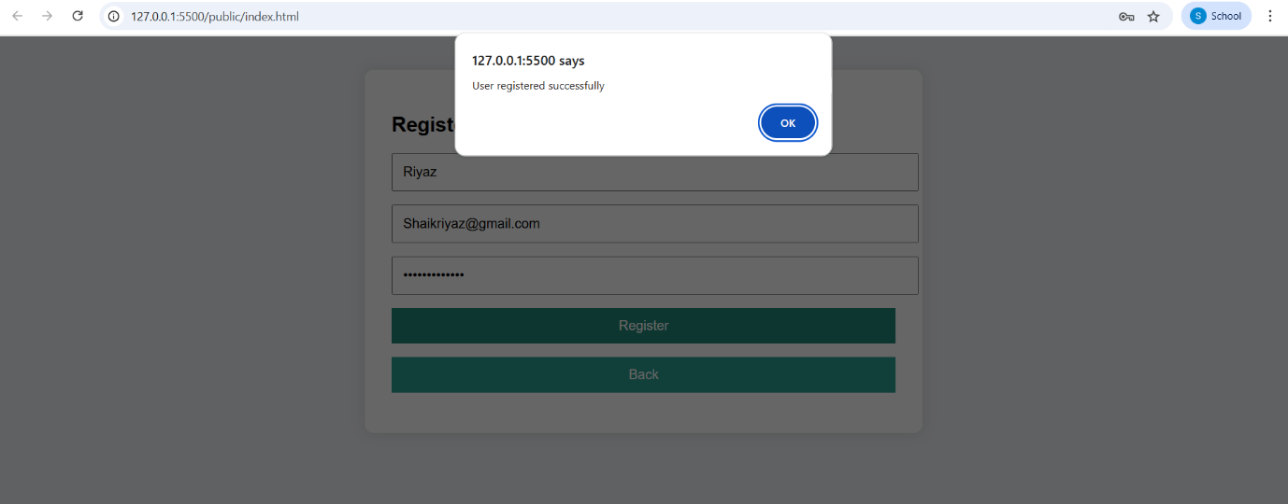

Registeration is successfully completed next step is to login with same information as registred to login in..

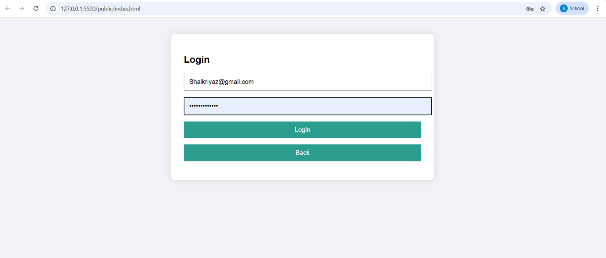

After Click on the Login button , We had logged in and Our Course Add Page will be openend

“Add Course” Section

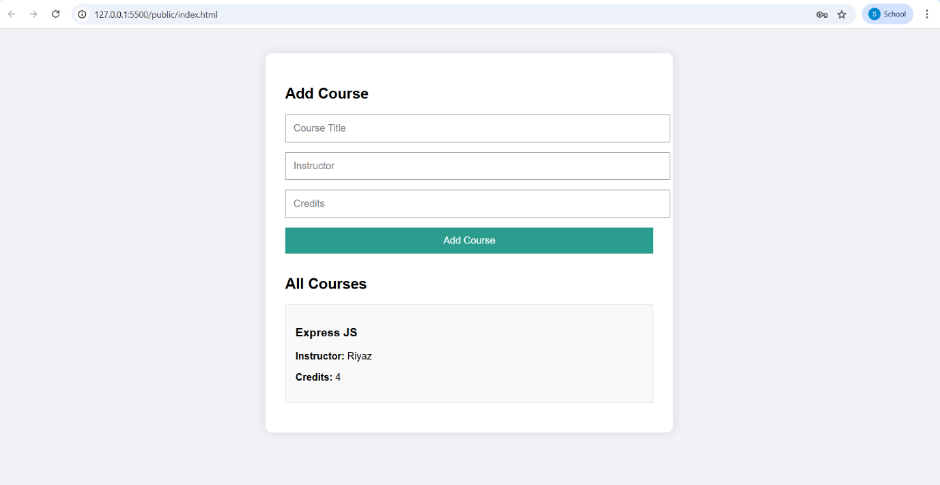

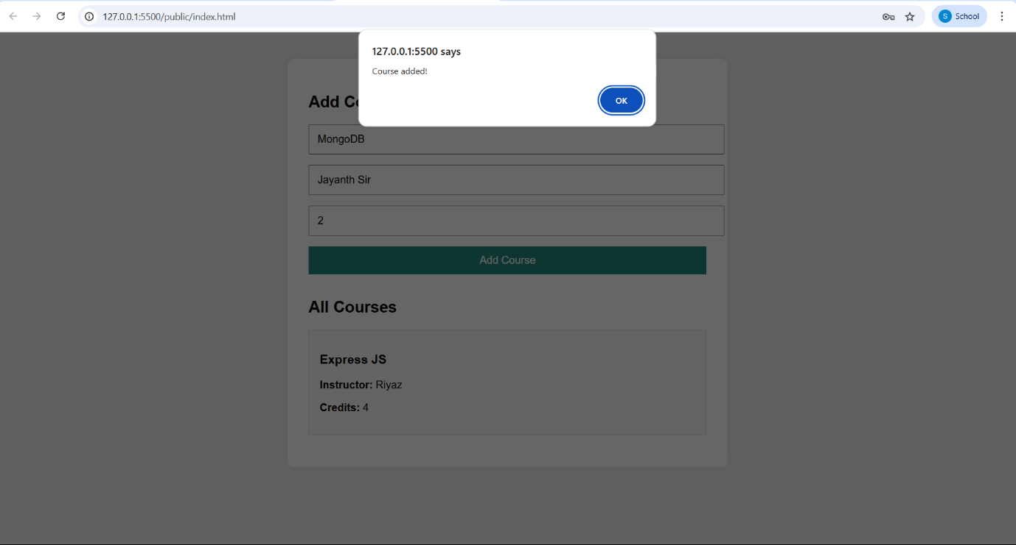

After Adding The course it shows the list of courses.

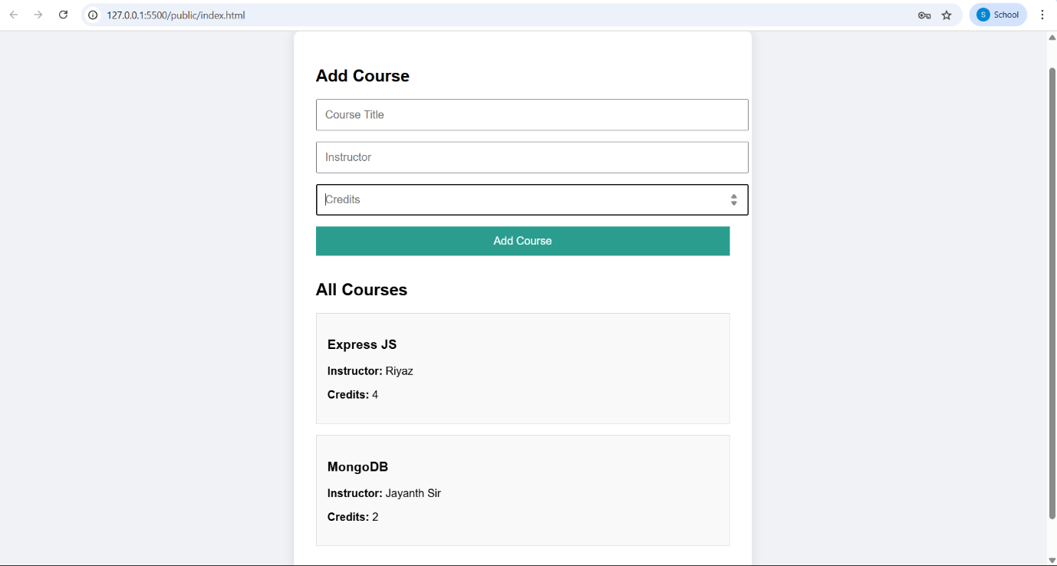

LOGIN & REGISTERATION IS DONE IN FRONTEND .

BACKEND LOGIN AND REGISTER THROUGH POSTMAN.

REGISTER

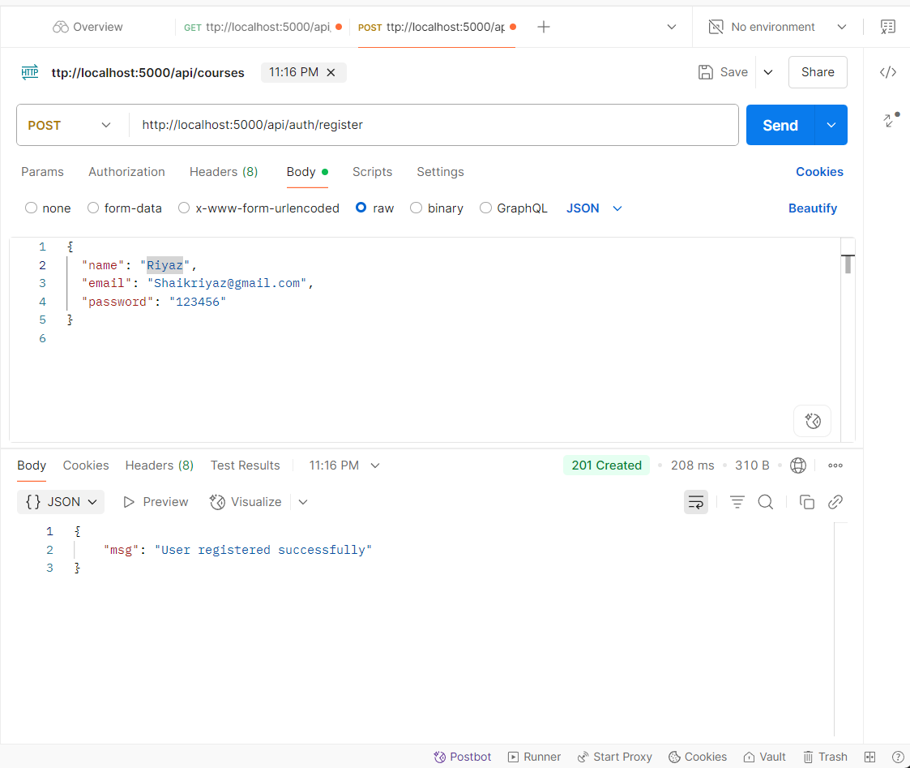

LOGIN

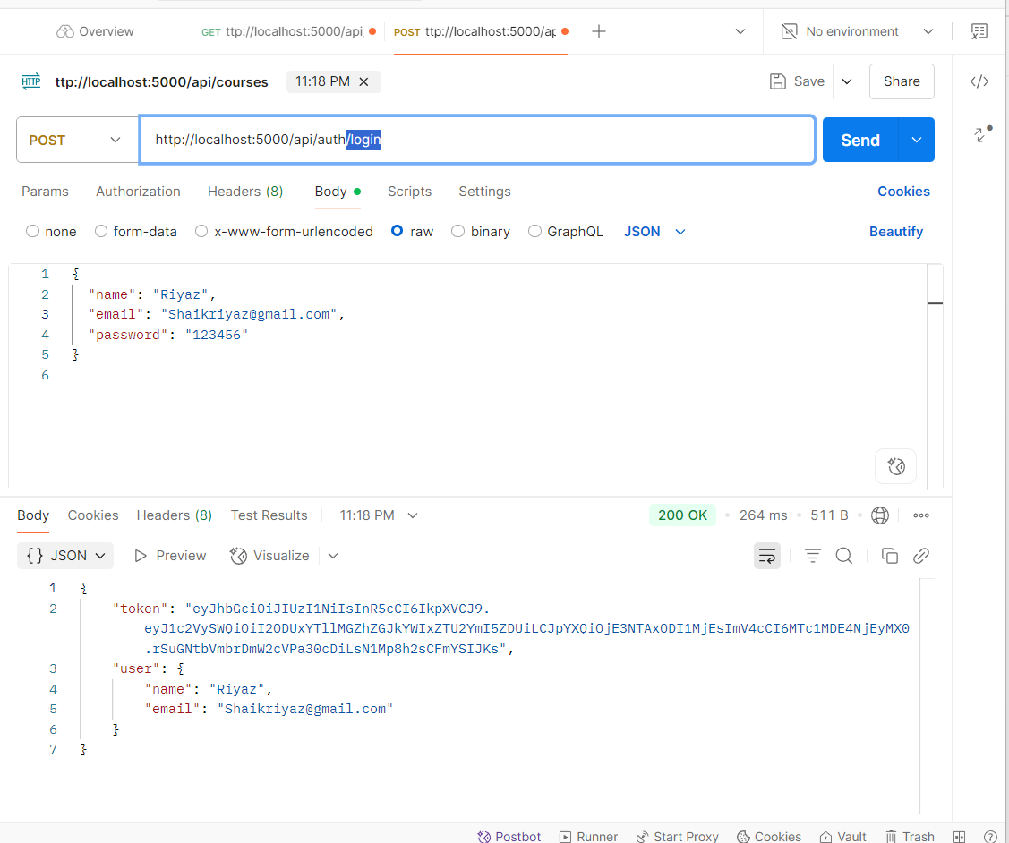

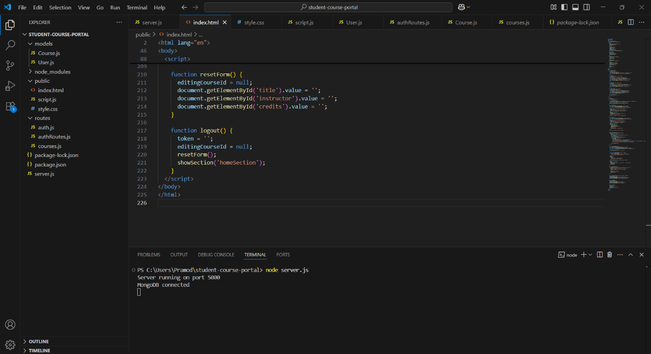

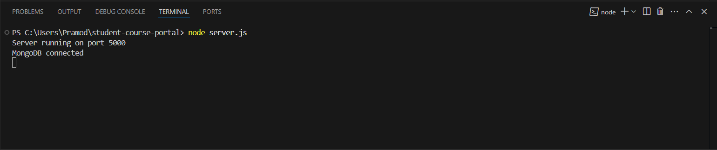

CRUD OPERATIONS

CREATE
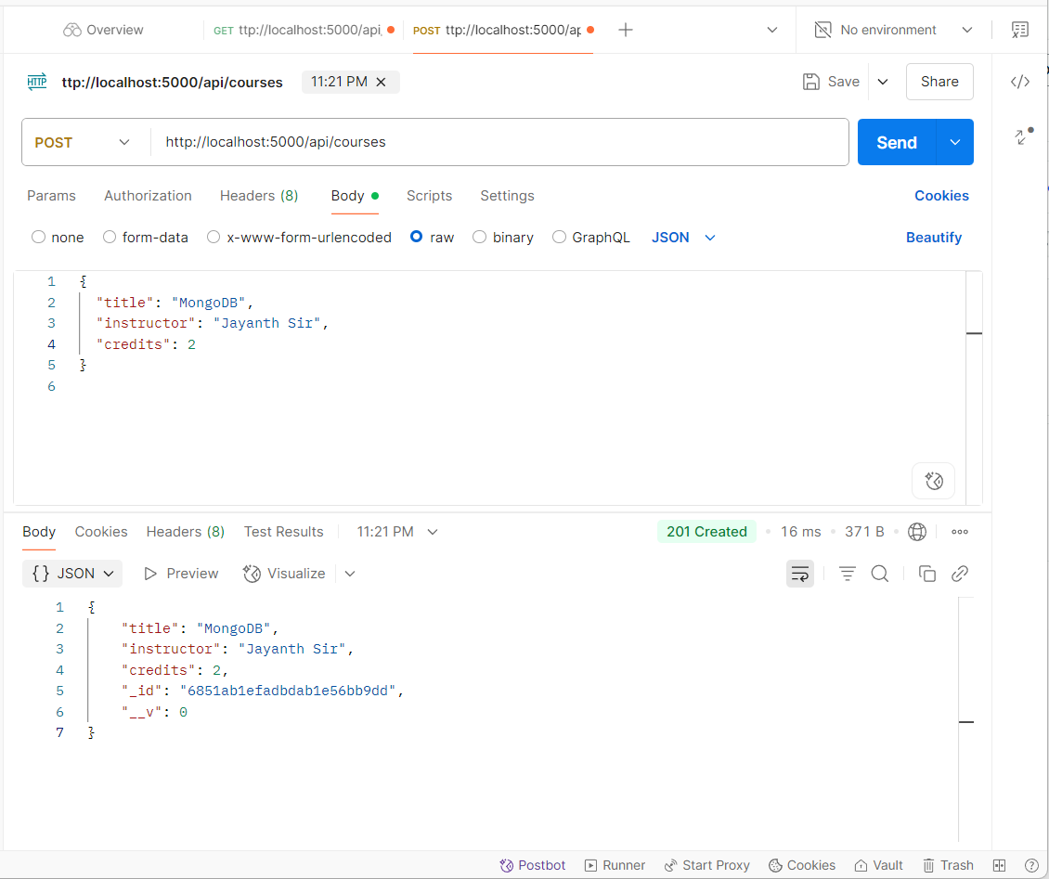

2.READ

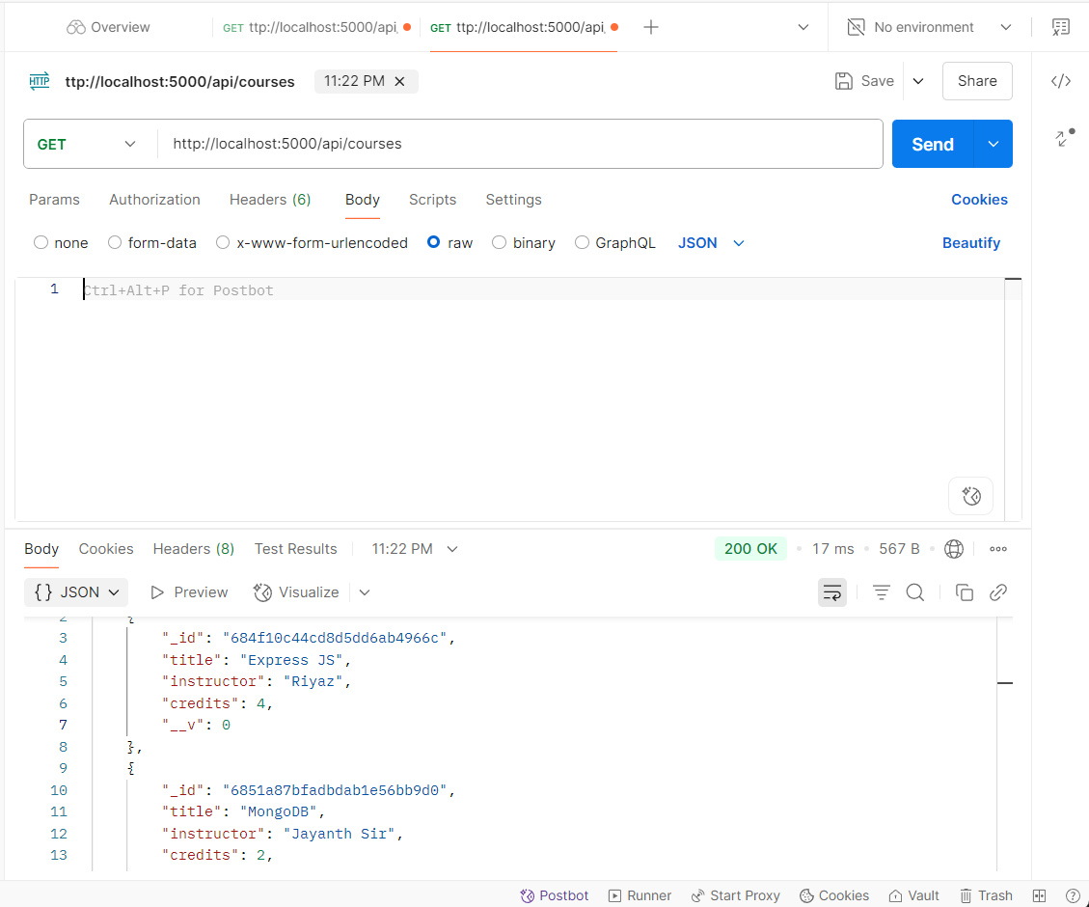

3.DELETE
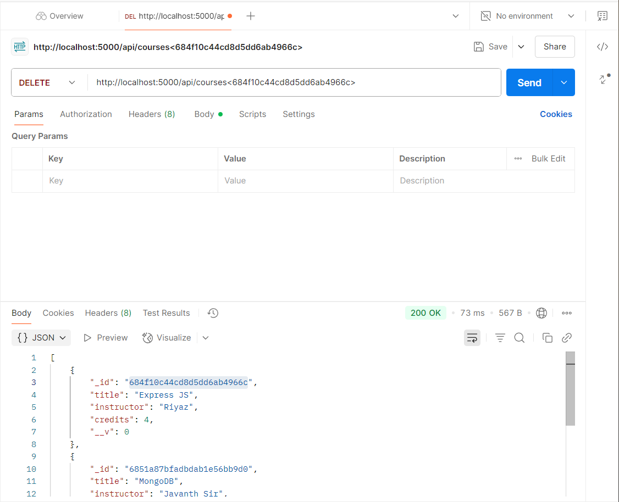
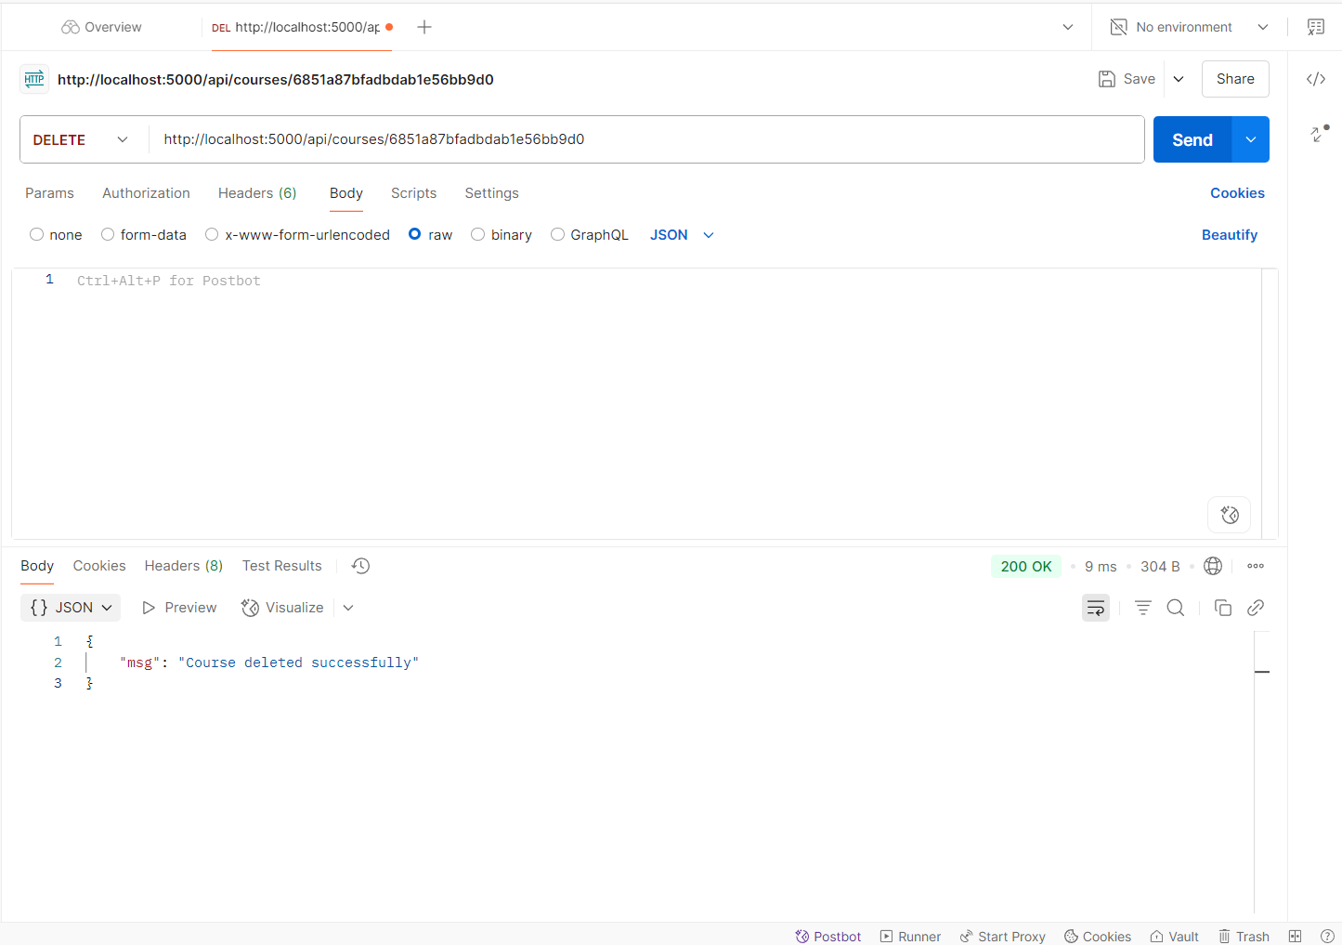

Title:- Express JS is deleted
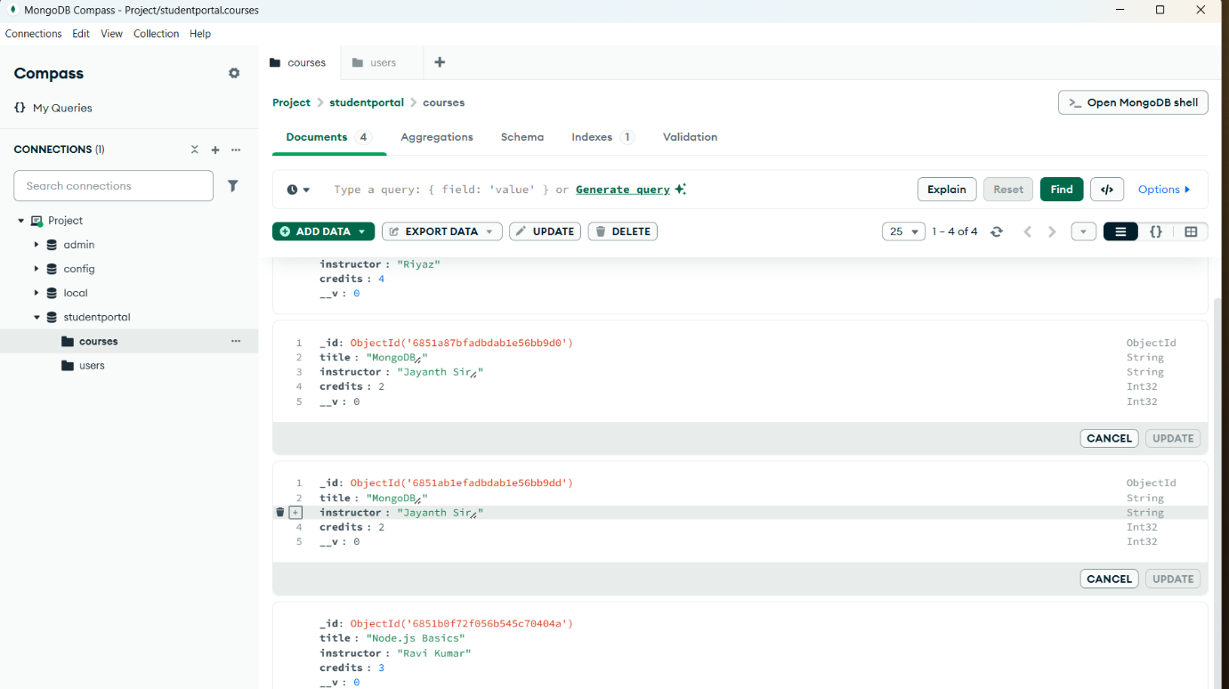

UPDATE
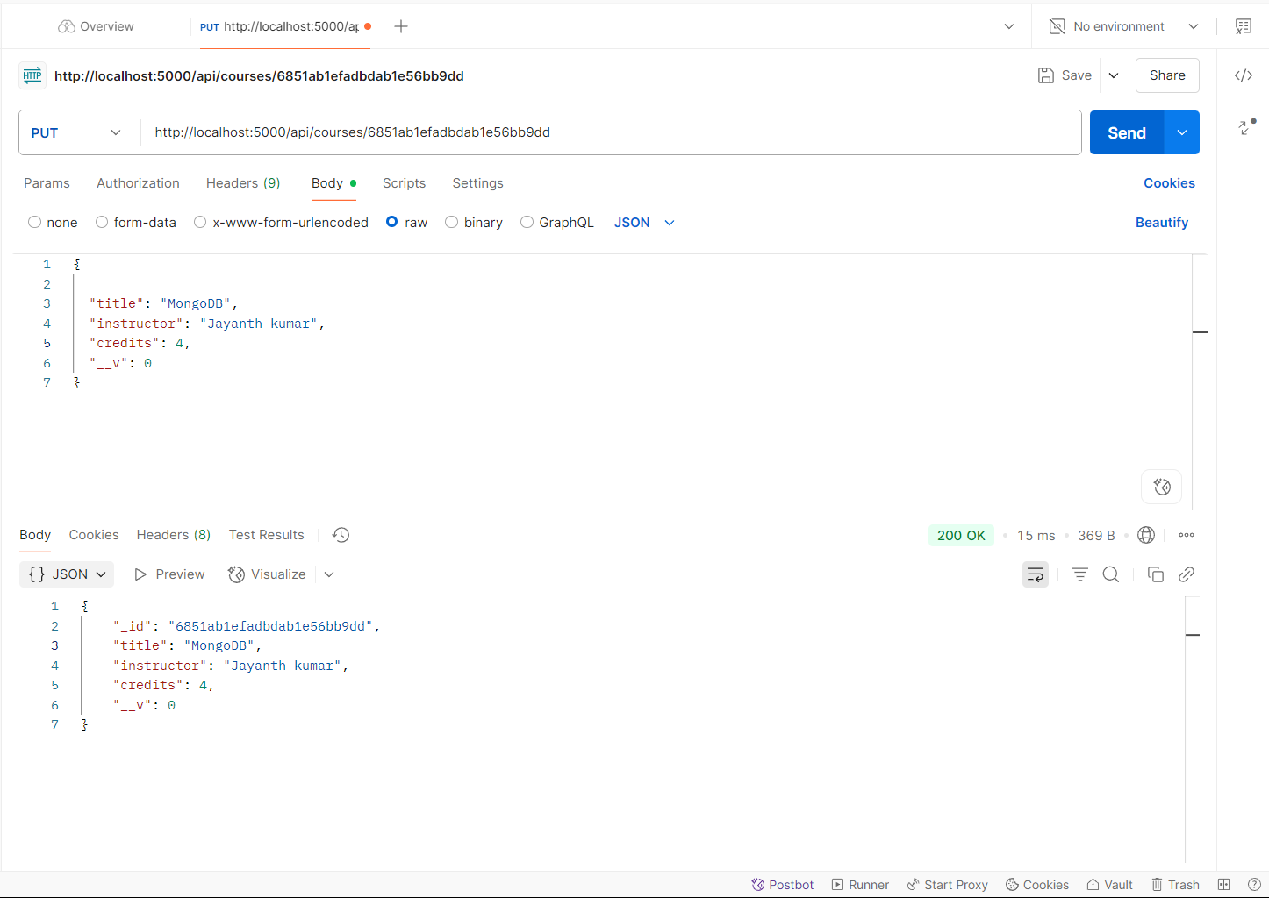

HERE UPDATE OPERATION IS USED.

Instructor name is updated.

After Updating And Deleting Operations
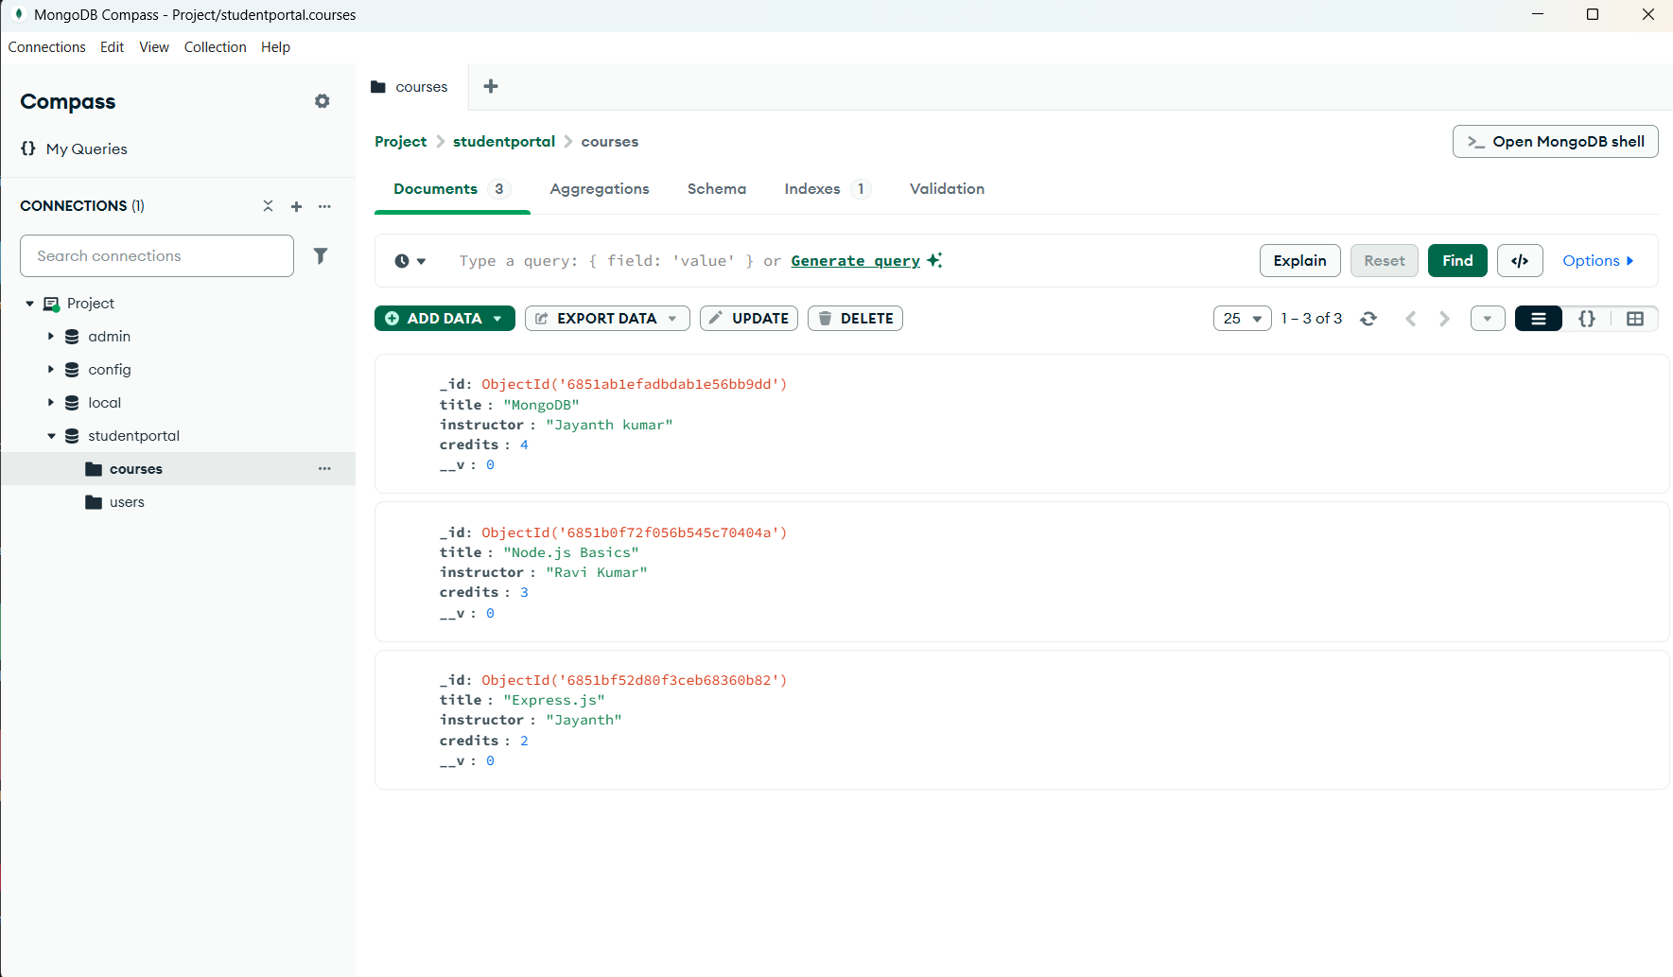

BEFORE AND AFTER CRUD OPERATIONS DATA IN MONGODB
BEFORE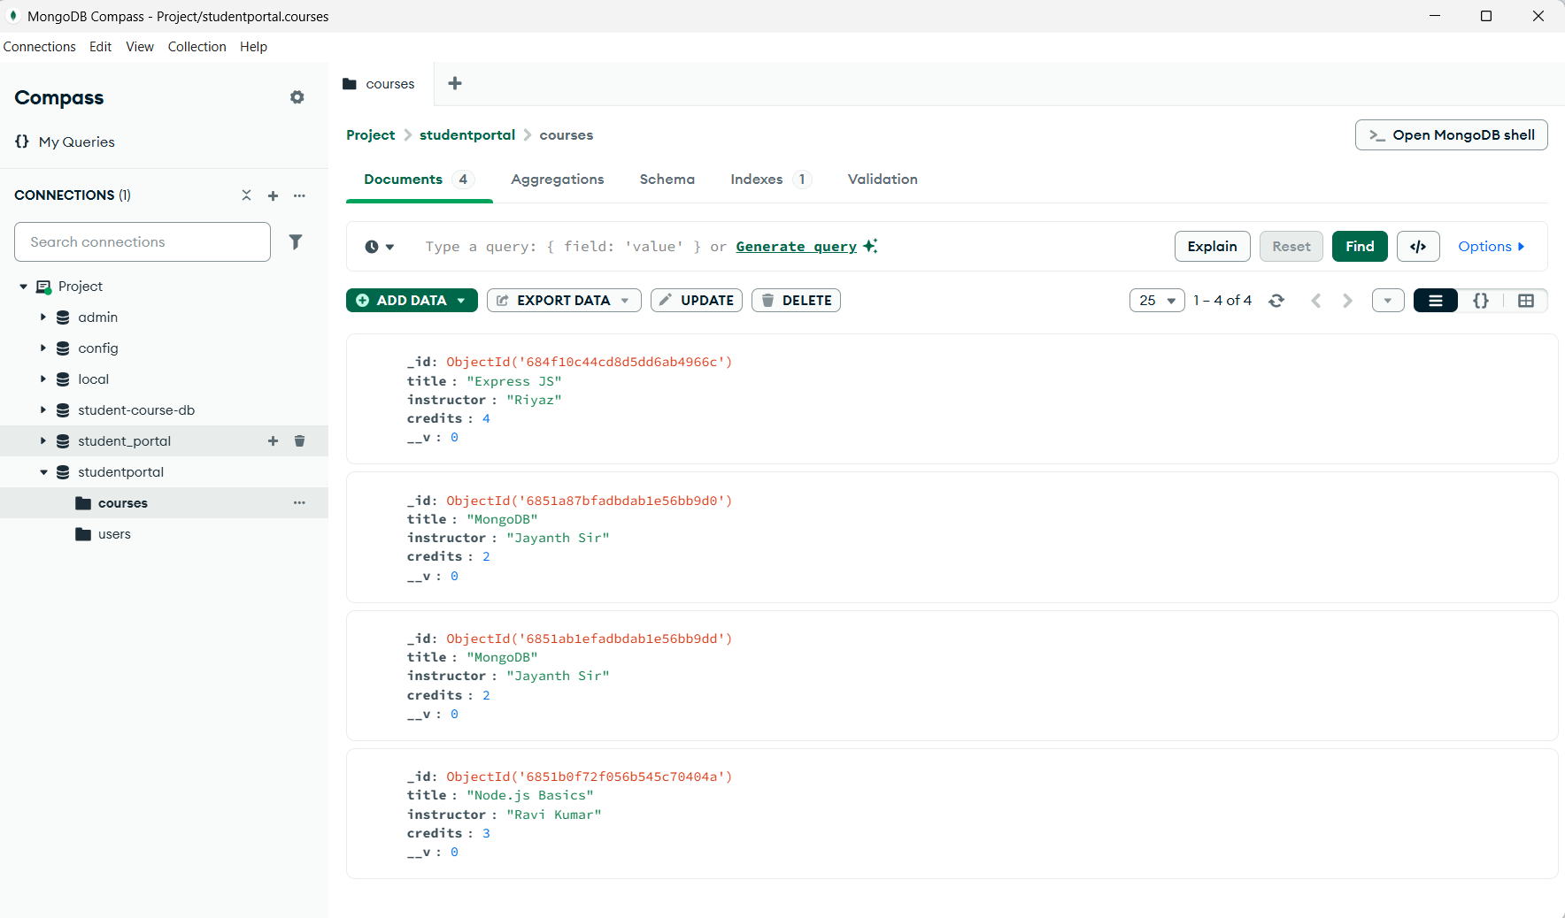

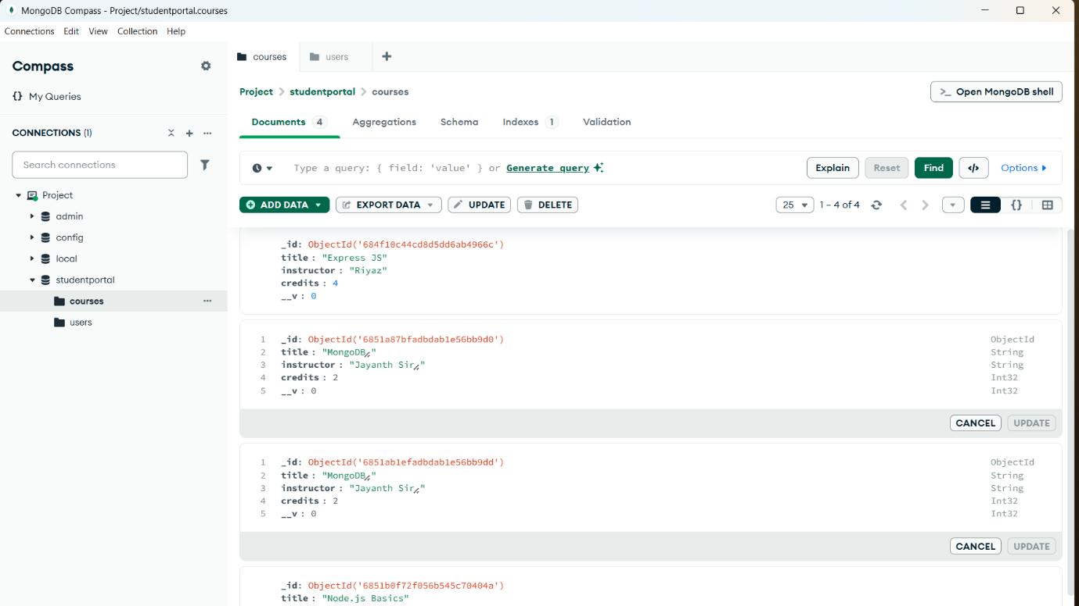

AFTER CRUD OPERATIONS

